Ka Pae ʻAina o Hawai’i Nei
The Hawaiian Archipelago Course

Instructors Guide

Course Description

Course Rationale or Need

A core geographical concept that students in Hawai’i are challenged with is the geography of the Hawaiian archipelago. Most students understand Hawai`i to be the eight major islands; however, the archipelago extends far beyond them. It is important that Hawai`i’s school children be educated about the Hawaiian archipelago as a whole and understand its history and significance. The unique characteristics of the Hawaiian archipelago make both face-to-face (traditional classroom setting) and online teaching an ideal tool to deliver instruction.

Course Goal

This course will cover the characteristics, historical background, and cultural significance of the Hawaiian archipelago. Given an face-to-face or online instructional module of the Hawaiian archipelago, Hawaii fourth grade students will be able to describe the entire Hawaiian archipelago by identifying the main Hawaiian Islands and the North West Hawaiian Islands (NWHI). They will be able to name at least four types of marine life, as well as, summarize the history and significance of the archipelago.

Intended Audience

The target population for this instructional module is Hawaii district public and private school fourth graders. The needed entry-level skills of the learner are basic computer and Internet navigation skills.

Course Content

Course Content
- Hawaiian Archipelago
  - What is it? Island or Atoll?
  - Characteristics, Location, Historical & Cultural Significance
- Unique Marine Species and Benthic Habitat Maps of the Hawaiian Archipelago

Course Outcomes/Objectives
After the completion of this course, it is anticipated the learner will be able to:
- Define island
- Define atoll
- Identify and list at least four unique marine species which inhabit the Hawaiian Archipelago
- Name the eight main and northwestern Hawaiian islands
- Use latitude and longitude to identify and locate the eight main and northwestern Hawaiian islands
- Summarize the history of the Hawaiian Archipelago (cultural, geographical, natural environment)
- Describe the Hawaiian Archipelago (cultural, geographical, natural environment)
- Design an online trading card that describes the cultural, geographical, and natural environment of the Hawaiian Archipelago.

Standards

Hawaii DOE Standards & Nā Honua Mauli Ola:
At the conclusion of this semester, the student will be able to:
Grade 4 Social Studies 7: Geography World in Spatial Terms Places and Regions
- SS.4.7.2 Collect, organize, and analyze data to interpret and construct geographic representations.
- SS.4.3.10 Describe how significant people, including those of legend (including Papa and Wākea, Pele, and Pa`ao) affected pre-contact Hawai’i
- LA.4.4.1 and LA.5.4.1 Write in a variety of grade-appropriate formats for a variety of purposes and audiences, such responses to literature and pieces to reflect on learning.

U.S. National Geography Standards
- How to Use Maps and Other Geographic Representations, Tools, and Technologies to Acquire, Process, and Report Information From a Spatial Perspective
1: The World in Spatial Terms

Course Structure

Class Meetings
This class can take place synchronously using a traditional classroom setting or the Blackboard Collaborate classroom. Twice a week is the suggested meeting or delivery of instructional time. In an online setting, it is highly recommended that students and teacher have a headset or microphone to connect to your computer so that you may participate in the in-class discussions and small-group activities.
Readings:
All course readings, supplement resources, videos, and slides will be linked in the weekly Ha’awina lesssons posted on the Hawaiian Archipelago website http://archipelagohawaiian.weebly.com.

Student Expectations
Excellence is expected throughout the course, demonstrated by timely participation and attendance; ongoing interaction and contributions to the class; effective collaboration during group tasks; careful evaluation and positive constructive feedback in peer review sessions. Students are expected to take responsibility for keeping up with assignment and readings.

Participation
Students in Hawaiian Archipelago are expected to participate in a cooperative, collaborative learning environment where all members (students, instructors, and educational assistants) are important resources and encouraged to work together for the pursuit of academic excellence. Due to the collaborative nature of the course, attendance, participation, and online netiquette in both synchronous and asynchronous activities are crucial. Students should inform and seek prior consent of the instructor if they cannot be present at any synchronous meetings or participate in asynchronous activities. (important requirement for online course delivery).

Professionalism
Students are expected to act professionally and to be courteous to fellow classmates at all times. Student effort, work habits, and behavior are important and will be evaluated separately from academic performance throughout the module course using the General Learner Outcome rubric.

General Learner Outcome (GLO) The six (GLOs) are:
- Self-directed Learner (The ability to be responsible for one's own learning)
- Community Contributor (The understanding that it is essential for human beings to work together)
- Complex Thinker (The ability to demonstrate critical thinking and problem solving)
- Quality Producer (The ability to recognize and produce quality performance and quality products)
- Effective Communicator (The ability to communicate effectively)
- Effective and Ethical User of Technology (The ability to use a variety of technologies effectively and ethically
- Rubric

National Education Technology Standards (NETS)
- Communication and Collaboration
Students use digital media and environments to communicate and work collaboratively, including at a distance, to support individual learning and contribute to the learning of others. Students:
- Contribute to project teams to produce original works or solve problems.
- Digital Citizenship
Students understand human, cultural, and societal issues related to technology and practice legal and ethical behavior.
Students:
- Exhibit a positive attitude toward using technology that supports collaboration, learning, and productivity.

Discussion Board Etiquette for Online Course Checklist
Student:
- refrains from using inappropriate language
- participates actively in two or more discussions
- never makes derogatory comments toward another person
- does not make sexist, racist, homophobic, or victim-blaming comments at all
- disagrees with ideas, but do not make personal attacks
- does not demean or embarrass others
- encourages others to develop and share their ideas
- is careful posting anything that is personal to myself or others
- when posting for a specific person or group, is sure to address it to them
- when responding to someone's comments, explains to whom and what you are commenting on, does not include their whole posting
- remembers to read what has previously been posted by others to avoid repeating comments
- makes sure to post under the appropriate heading or thread

Avoid slang (e.g., "Wassup?", "Yo," and so forth)  don't curse  use standard spelling:  you (not u) | are (not r)  to or too (not 2)  you're (not ure)  right (not rite)  I (not i)

Peer Feedback
Peer feedback is a vital part of the learning process in this course. The instructor reserves the right to lower any student’s grade for not engaging in discussion, providing thoughtful feedback, or general non-participation.

Hardware and Software

Required Hardware
- The student or school will need an active Internet connection capable of running a current web browser such as Firefox, Chrome, Safari or Internet Explorer.

Software Requirements
- Word Processing Application (i.e. Microsoft Office – Word, Open Office.)

Assignments

List of Assignments and Due dates (tentative schedule)
Item | Due | Points
Assignment 1 – Introduction Post & Discussion | 8/22 | 50
Assignment 2 – Unique Marine Species | 8/25 | 50
Assignment 3 – Quiz | 8/25 | 50
Assignment 4 – Eight Main Hawaiian Islands | 8/29 | 50
Assignment 5 – Quiz | 9/2 | 50
Assignment 6 – Summarize the Hawaiian Archipelago | 9/4 | 50
Assignment 7 – Create Trading Cards | 9/5 | 80

Assignment Quality and Deadlines:
All assignments are due on the dates indicated. Late assignments are accepted for credit only with permission of the instructor.
- Students are responsible for assignment deadlines and following directions carefully.
- All assignments are to be checked for correct grammar, spelling, capitalization, and punctuation.
- Students are expected to complete all assignments to receive a passing grade for the unir/module.
- Week 1: Ha`awina `Ekahi (Tuesday)

Assignment 1
Do discussion post. Introduce yourself to other students in the forums.
- What is your name?
- What island are you from?
- What district/town/city do you live in?
- Share about a special place on your island.
Post in the Blog discussion area of Blackboard, 3 facts that you've learned about the Hawaiian Archipelago today. Respond to at least two of your fellow students postings. Introduction and discussion response is due by next class session on Thursday

Focus Questions
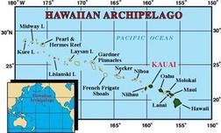
We will learn about the Hawaiian Archipelago and the different islands and atolls that are found in it.
- Do you know what the Hawaiian Archipelago is?
- What do you know about it? Have you ever heard your family mention it?
We will also learn some facts about the Hawaiian Archipelago
- The main islands are in the Southern part of the Pacific and are inhabited
- There are many more islands to the North mostly uninhabited, together they make up the Hawaiian Archipelago.
- There are 8 main islands, not 7? Did you know that?
- Review a map of the Hawaiian Archipelago
The Hawaiian Archipelago includes two types of landmasses - islands and atolls.
Week 1: Ha`awina `Elua (Thursday)
Activity 1(In-class)
What I've learned
We will review last week’s discussion assignment.

Assignment 1 (In-class)
With a partner, explore the websites and learn more about the marine life of the Hawaiian Archipelago. Then complete the Who am I? Activity.

Activity 2 (In-class)
Marine Life of the Hawaiian Archipelago
We will take a virtual trip to various websites to learn more about the marine life found in the Hawaiian Archipelago.

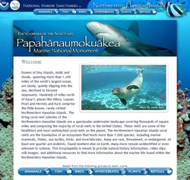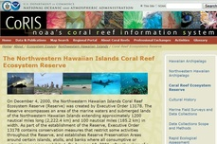

Week 2: Ha`awina `Ekolu (Tuesday)
Eight MHI Latitude & Longitude
Where is your location on earth?
What is latitude?
What is longitude?
Related Links

Focus Questions & Activities
- Where are Nā Mokupuni `o Hawai'i - the Hawaiian Islands - located?
- How would you compare the major physical characteristics of the eight Hawaiian Islands?
- Explore, discover, and investigate the various interactive maps listed below to gather the geographical locations, names, and charactistics of the eight main Hawaiian Islands.

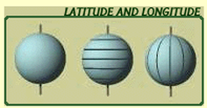

Activity 1:
Where are Nā Mokupuni `o Hawai'i - the eight main Hawaiian Islands?
Why is the mo'olelo of Papahānaumoku and Wākea culturally significant?
What are the ancient names of the eight Hawaiian Islands?

Activity 2:
Can you locate the eight main islands using latitude and longitude?
What are the unique characteristics of each island?
http://en.wikipedia.org/wiki/Hawaiian_Islands

Week 2: Ha`awina `Eha (Thursday)
Description and Environment of the Northwestern Hawaiian IslandS

Focus Questions & Activities
Where are the “kupuna” islands—Northwestern Hawaiian Islands (NWHI) - located?
How would you compare the major physical characteristics of the different NWHI?

Activity 1:
Where are the “kupuna” islands?
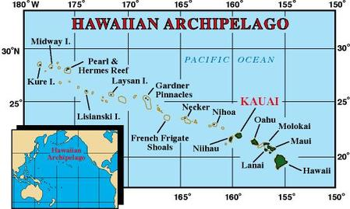
Key Concepts
The Northwestern Hawaiian Islands include 3 types
of islands:
- Nihoa, Necker, and Gardner Pinnacles are islands with volcanic basalt cliffs.
- Laysan and Lisianski are coral islands with fringing reefs.
- French Frigate Shoals, Maro Reef, Pearl and Hermes Reef, Midway, and Kure are atolls.

Week 3: Ha`awina `Elima (Tuesday)

Activity 1 - Continue to explore Learning Object websites and revisit previous sites.
Assignment 1 (In-class)
With a partner, fill-in the Hawaiian Archipelago Worksheet. Post your responses on the whiteboard in your breakout rooms. Refer to the links on this webpage and use the resource links and learning objects to help you complete the worksheet.
Assignment 2
Create Trading Cards - Use the completed worksheet template and http://bighugelabs.com to create online trading cards that describe the Hawaiian archipelago. Post your Trading Cards in Laulima. Click here to see the rubric.
Criteria
Trading cards must include:
- at least one image
- a main title/sub title (kupuna island name/ancient name)
- common name/sub scientific name (marine life)
- 3 facts (i.e. is it an island or atoll, location, lat/longitude, size,
cultural importance, chief, age etc)
Hawaiian Archipelago Worksheet
Mo’olelo and Ancient Names of the Hawaiian Archipelago

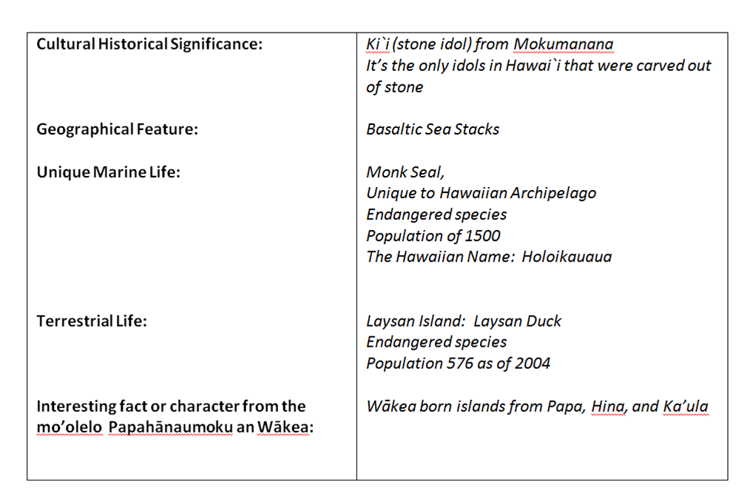
Example:

Week 3: Ha`awina `Eono (Thursday) - Final Project

Final Project Guidelines
Trading cards must include:
- at least one image
- a main title/sub title (kupuna island name/ancient name)
- common name/sub scientific name (marine life)
- 3 facts (i.e. is it an island or atoll, location, lat/longitude, size, cultural, chief, age etc)
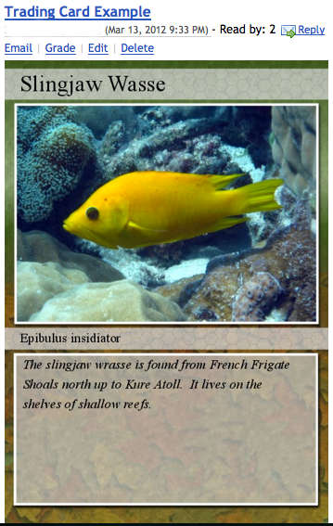

Hawaiian Archipelago Final Project Rubric
TOPIC:______________________________ MEANS OF PRESENTATION _____________________

CATEGORY | 4 I MUA! | 3 Maika`i | 2 Waena | 1 Uwe
Originality | Presentation shows considerable originality and inventiveness. The content and ideas are presented in a unique and interesting way. | Presentation shows some originality and inventiveness. The content and ideas are presented in an interesting way. | Presentation shows an attempt at originality and inventiveness on 1-2 cards, slides, or items. | Presentation is a rehash of other people's ideas and/or graphics and shows very little attempt at original thought.
Content - Accuracy | All content throughout the presentation is accurate. There are no factual errors. | Most of the content is accurate but there is one piece of information that might be inaccurate. | The content is generally accurate, but one piece of information is clearly flawed or inaccurate. | Content is typically confusing or contains more than one factual error.
Sequencing of Information | Information is organized in a clear, logical way. It is easy to anticipate the type of material that might be on the next card, slide, or item.. | Most information is organized in a clear, logical way. One card, slide, or item of information seems out of place. | Some information is logically sequenced. An occasional card, slide, or item of information seems out of place. | There is no clear plan for the organization of information.
Use of Graphics, Drawings, Appropriate Special Effects, etc. | All graphics are attractive (size and colors) and support the theme/content of the presentation. | A few graphics are not attractive but all support the theme/content of the presentation. | All graphics are attractive but a few do not seem to support the theme/content of the presentation. | Several graphics are unattractive AND detract from the content of the presentation.
Effectiveness | Project includes all material needed to gain a comfortable understanding of the topic. It is a highly effective piece | Project includes most material needed to gain a comfortable understanding of the material but is lacking one or two key elements. It is an adequate piece | Project is missing more than two key elements. It would make an incomplete piece. | Project is lacking several key elements and has inaccuracies that make it a poor piece

Points: ______ ______ ______ ______

Final Score: _____
Comments:

* NOTE: Permission granted by Celeste Volivar-Fry to use and modify rubric.

Grading
Grading Criteria
Final grades will be determined using the following scale:
A+ | 100% | B+ | 87-89% | C+ | 77-79% | D+ | 67-69%
A | 95-99% | B | 84-86% | C | 74-76% | D | 64-66%
A- | 90-94% | B- | 80-83% | C- | 70-73% | D- | 60-63%
F = | Below 60%

Course Site Components

Weebly Website
(A course management system such as Blackboard could be used similarly to house content)
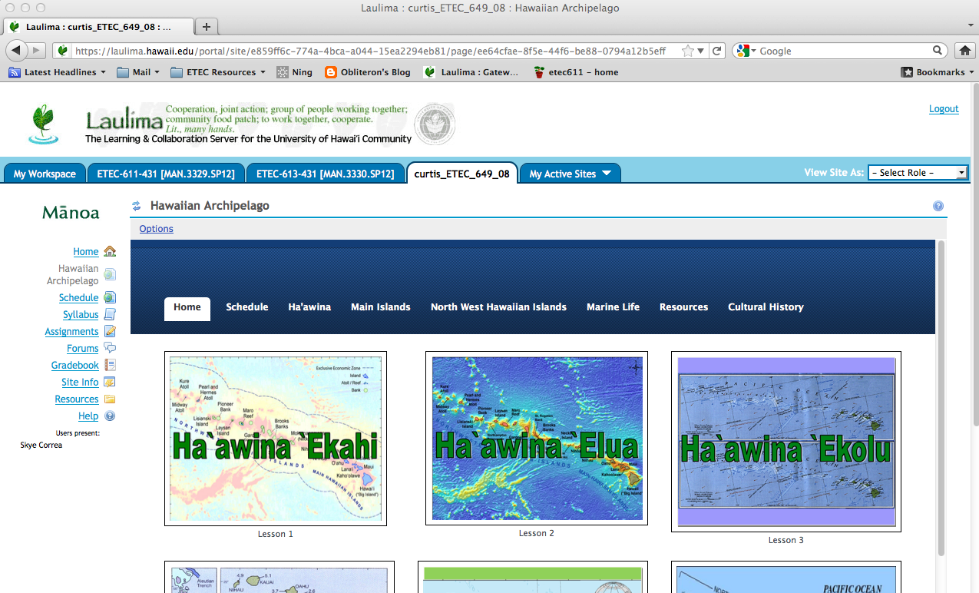

Laulima Course Management System
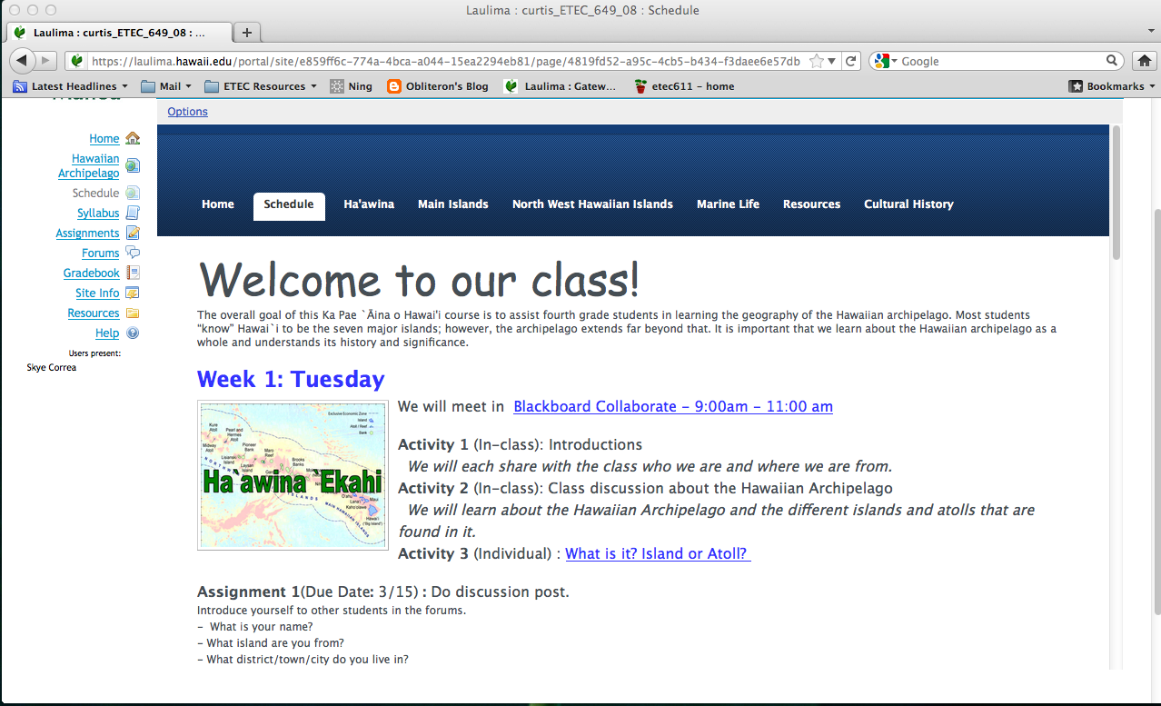

Blackboard Collaborate
(Synchronous meetings can occur in Blackboard Collaborate)
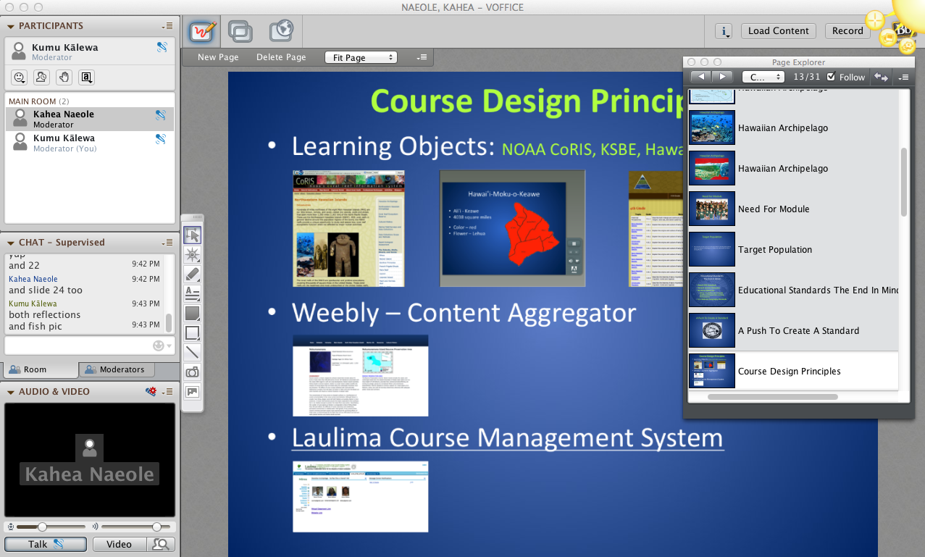

Course Schedule

Weeks  (Tentative) | Learning Content | Discussions | Assignments  Ha’awina
Week 1:  Tuesday 8/21  We will meet in  Blackboard Collaborate - 9:00am - 11:00 A.M. | We will learn about the Hawaiian Archipelago and the different islands and atolls that are found in it. | Activity 1 (In-class):  Introductions  We will each share with the class who we are and where we are from.  Activity 2 (In-class): Class discussion about the Hawaiian Archipelago  Activity 3 (Individual): What is it? Island or Atoll? | Assignment 1: (Individual work)  (Due Date: 8/22) :  Do discussion posts -Introduction Post & Hawaiian Archipelago Discussion  Introduce your-self to other students in the Blog forums.  - What is your name?  - What island are you from?  - What district/town/city do you live in?  - Share about a special place on your island.  Post in the Blog forum area of Blackboard, 3 facts that you've learned about the Hawaiian Archipelago today. Respond to at least two of your fellow students’ postings.  Introduction and discussion response is due by next class session on Thursday.
Thurs 8/23  We will meet in  Blackboard Collaborate - 9:00am - 10:00  A.M. | We will take a virtual trip to some websites to learn more about the marine life found in the Hawaiian Archipelago | Activity 1 (In-class): What I've learned  We will review Tuesday’s discussion assignment.  Activity 2 (In-class): Marine Life of the Hawaiian Archipelago  . | Assignment 1  (Due Date: 8/25 ):  With a partner, explore the websites and learn more about the marine life of the Hawaiian Archipelago.  Then complete the Who am I? activity.  Refer to the resource links below located on the Ka Pae `Aina o Hawai’i weebly website http://hawaiianarchipelago.weebly.com.  Papahānumokuakea  The Northwestern Hawaiian Islands Coral Reefs Ecosystem Reserves  Assignment 2  (Due Date: 8/25 ):  Do the section quiz
Week 2:  Tuesday 8/28  We will meet in  Blackboard Collaborate - 9:00am - 10:00  A.M. | Discover the 8 main Hawaiian islands  We will learn about the location of the Hawaiian Archipelago - Main Islands. | Activity 1 (In-class):  We will have a class discussion and some polling questions to see how much we already know about the main islands.  Where are Nā Mokupuni `o Hawai'i - the eight main Hawaiian Islands?  Why is the mo'olelo of Papahānaumoku and Wākea important?  What are the ancient names of the eight Hawaiian islands?  Activity 2 (In-class): Latitude & Longitude | Assignment 1  (Due Date 8/29):  Do discussion post - Papahānaumoku and Wākea Moʻolelo & Ancient Island Names  Post three reasons why the moʻolelo of Papahānaumoku and Wākea are important to the history of the Hawaiian Archipelago?  Additionally, list the ancient names of the eight Hawaiian islands drawing your information from the website.
Thurs 8/30  We will meet in  Blackboard Collaborate - 9:00am - 10:00  A.M. | We will learn about the location of the Hawaiian Archipelago - NWHI. | Activity 1 (In-class):  Discover the Northwestern Hawaiian Islands  Where are the “kupuna” islands?  Cultural History of the Northwestern Hawaiian Islands  Activity 2 (In-class): Latitude & Longitude  We will learn about the location of the Hawaiian Archipelago - NWHI. | Assignment 1:  Continue to explore the Northwestern Hawaiian Islands link on our website.  Assignment 2:  (Due Date: 9/2):  Do the section quiz
Week 3: Tuesday 9/4  We will meet in  Blackboard Collaborate - 9:00am - 10:00  A.M. | We will learn more about the cultural importance of the Hawaiian Archipelago. | Activity 1 (In-class): The Hawaiian Archipelago  We will review last week’s assignment and take a virtual trip to learn more about the cultural importance of the Hawaiian Archipelago.  Then we will review the requirements for the final project Trading Cards. | Assignment 1  (Due Date 9/4):  With a partner, fill-in the Hawaiian Archipelago Worksheet. Post your responses to the whiteboard in your breakout rooms. Refer to the links on this webpage and use the resource links and learning objects to help you complete the worksheet. The whiteboards from the breakout sessions in Blackboard Collaborate will be posted by the instructors to the forum. We will use the postings as a guide for the final project. Feedback for other groups postings are not required, but are encouraged.  Assignment 2  (Due Date 9/5):  Create Trading Cards (Teams) - Use the completed worksheet template and http://bighugelabs.com to create the online trading cards that describe the Hawaiian archipelago. Post your Trading Cards in Laulima.
Thursday 9/6  We will meet in  Blackboard Collaborate - 9:00am - 10:00  A.M. | We will review some of the trading cards posted on the forum. | Activity 1 (In-class): What have I learned?  We will review some of the trading cards posted on the forum | Assignment 1  (Due Date 9/6)  Forum Response Post – Please read through the other groups post and reply to at least 4 groups’ post.

Resources

Northwestern Hawaiian Islands Multi-Agency Education Project
http://www.hawaiianatolls.org/teachers/NavChange.php
Hawaii State Symbols
http://www.statesymbolsusa.org/Hawaii/Hawaii-state-symbols.html
Mokumanamana
http://hawaiialive.org/standards.php?sub=4th+Grade&Subtopic=121
Moʻolelo of Papa and Wākea
http://hawaiianarchipelago.weebly.com/moolelo-o-papahaumlnaumoku-and-waumlkea.html
Cultural History of the Northwestern Hawaiian Islands
http://coris.noaa.gov/about/eco_essays/nwhi/history.html
NOAA Coral Reef Conservation Program
http://coralreef.noaa.gov/
Northwestern Hawaiian Islands
http://www8.nos.noaa.gov/onms/park/Parks/?pID=12
Navigating Change
A Teacher's Guide to Navigating Change (Revised 2008 Curriculum)
Introduction (pdf 1.69 MB)
Unit 1 - The Voyage (pdf 2.83 MB)
Unit 2 - Land To Sea Connection (pdf 6.24 MB)
Unit 3 - Change Over Time (pdf 7.2 MB)
Unit 4 - Human Impact: Part 1 (pdf 5.27 MB) & Part 2 (pdf 6.5 MB)
Unit 5 - You Make The Difference (pdf 1.1 MB)

